INSERT TRUST LOGO



**Clinician pack- Routine clinical assessment for ARMS**

**This assessment pack is to be used with all new assessments for potential ARMS referrals. It includes the CAARMS interview questions (with improved and easier scoring pages) and the additional clinically useful measures.**

**Please complete the information as fully as possible. The research assistant will transfer this information anonymously to the research database and help with scoring measures. This assessment can then be stored/uploaded in the patient’s notes.**

*For the purpose of brevity, each score is denoted by the primary anchor listed in the measure however please use secondary anchors and the CAARMS manual to guide ratings.



**Clinician pack**

**Version 4 01.02.2021**

**IRAS ID : 272880**

|  |  |  |  |  |  |  |  |  |  |  |  |  |  |  |  |  |  |  |  |  |
| --- | --- | --- | --- | --- | --- | --- | --- | --- | --- | --- | --- | --- | --- | --- | --- | --- | --- | --- | --- | --- |
| **NHS NUMBER** |  | |  | |  | |  | |  | |  | |  | |  | |  |  |  |  |
|  |  | |  | |  | |  | |  | |  | |  | |  | |  |  |  |  |
| **DATE** | D | D | | M | | M | | Y | | Y | | Y | | Y | |
|  |  | |  | |  | |  | |  | |  | |  | |  | |  |  |  |  |  |  |
| **CLINICIAN INITIALS** |  | |  | |  | |  | |  | |  | |  | |  | |  |  |  |  |  |  |

**Contents**

**SECTION A IS COMPLETED BY THE RESEARCH ASSISTANT.**

Section B: CAARMS 4

1. CAARMS: Unusual Thought Content 6

2. CAARMS:Non-Bizarre Ideas 8

3. Perceptual Abnormalities 10

4. Disorganised Speech 12

5. Aggression/Dangerous Behaviour 14

6. Suicidality and Self Harm 16

SECTION C: Social and Occupational Functioning Assessment Scale 18

SECTION D: ARMS/PSYCHOSIS GROUP 19

SECTION E: Rey Auditory Verbal Learning Test (RAVLT) 21

SECTION F: Digit symbol substitution test 24

## Section B: CAARMS

**Overview Of The CAARMS**

***Aims****:*

* To determine if an individual meets the criteria for an ‘At Risk Mental State’.
* To rule out, or confirm criteria for acute psychosis.
* To map a range of psychopathology and functioning factors, over time in young people at ultra high-risk of psychosis.

***Structure of the CAARMS:***

* Ratings are made on a range of subscales that target different areas of psychopathology and functioning. From these ratings it is then possible to extract information relating to the above aims.

***Overview of Symptoms and Functioning - Longitudinal Change:***

* At the first interview (not follow-up interviews), the CAARMS aims to obtain a general overview of the history of change from the premorbid state in the respondent. All available information should be used.
* Record the **time of first noted change** - date and age of respondent in years:

Date: ………………………………

Age: ………………………………

* Note first ever symptoms or signs:

………………………………………..……

………………………………………..……

………………………………………..……

………………………………………..……

………………………………………..……

* Overview of course since then - map on timeline e.g.:

First change Worst ever

* Current time line:

First change Worst ever

* **Family history of psychosis** in first degree relative? ……………………………………..
* **If yes, please state who** ……………………………………..
* **Use of medication (current or past)?** ……………………………….………………………………………………………………….…

**NOTE:** For the BLIPS group, the ONSET and OFFSET dates need to be recorded for each episode (not very first onset date and very last offset date), as to qualify under BLIPS criteria, symptoms cannot last more than a week at a time

**Helpful prompt questions:**

* How often does it happen?
* When did it last happen?
* Does it stop you from doing anything?
* When was it at its worst?
* What was it like at the worst point?
* What do your friends and family say about it?
* How distressed were you?
* How long does it last?
* Do other people see it the same way?
* Can you give me a specific example of that?
* Has it changed you behaviour in any other way?

Present state Time

Present state Time

### CAARMS: Unusual Thought Content

***Delusional Mood and Perplexity (‘Non Crystallized Ideas’)***

|  |  |
| --- | --- |
| * Have you had the feeling that something odd is going on that you can’t explain? What is it like? * Do you feel puzzled by anything? Do familiar surroundings feel strange? * Do you feel that you have changed in some way? * Do you feel that others, or the world, have changed in some way? |  |

***Bizarre Ideas (‘Crystallized Ideas’)***

|  |  |
| --- | --- |
| * Made thoughts, feelings, impulses: Have you felt that someone, or something, outside yourself has been controlling your thoughts, feelings, actions or urges? Have you had feelings or impulses that don’t seem to come from yourself? * Somatic Passivity: Do you get any strange sensations in your body? Do you know what causes them? Could it be due to other people or forces outside yourself? * Thought Insertion: Have you felt that ideas or thoughts that are not your own have been put into your head? How do you know they are not your own? Where do they come from? * Thought Withdrawal: Have you ever felt that ideas or thoughts are being taken out of your head? How does that happen? * Thought Broadcasting: Are your thoughts broadcast so that other people know what you are thinking? * Thoughts Being Read: Can other people read your mind? |  |

|  |  |
| --- | --- |
| * Ideas of Reference: Have you felt that things that were happening around you had a special meaning, or that people were trying to give you messages? What is it like? How did it start? |  |

***Ideas of Reference (NOT in relation to suspiciousness and persecutory ideas)***

|  |  |  |  |  |  |  |  |  |  |  |  |  |  |
| --- | --- | --- | --- | --- | --- | --- | --- | --- | --- | --- | --- | --- | --- |
| 1. **UNUSUAL THOUGHT CONTENT** | | | | | | | | | | | | | |
| **1a. Global rating** | | 0 | No unusual thought content | | | | | | | | | | |
| 1 | Mild elaboration of conventional beliefs as held by a proportion of the population | | | | | | | | | | |
| 2 | Vague sense that something is different, or not quite right with the world, a sense that things have changed but not able to be clearly articulated | | | | | | | | | | |
| 3 | A feeling of perplexity. A stronger sense of uncertainty regarding thoughts than 2. | | | | | | | | | | |
| 4 | Referential ideas that certain events, objects or people have a particular and unusual significance.  Feeling that experience may be coming from outside the self. Belief not held with conviction, subject able to question. | | | | | | | | | | |
| 5 | Unusual thoughts that contain completely original and highly improbable material.  Subject can doubt (not held with delusional conviction), or which the subject does not believe all the time. | | | | | | | | | | |
| 6 | Unusual thoughts containing original and highly improbable material held with delusional conviction (no doubt). | | | | | | | | | | |
| **1b. Frequency and duration** | | 0 | Absent | | | | | | | | | | |
| 1 | Less than once a month | | | | | | | | | | |
| 2 | Once a month to twice a week **– less** than one hour per occasion | | | | | | | | | | |
| 3 | Once a month to twice a week – **more** than one hour per occasion  **OR**  3 to 6 times a week - **less** than one hour per occasion | | | | | | | | | | |
| 4 | 3 to 6 times a week - **more** than an hour per occasion  **OR**  daily – **less** than an hour per occ. | | | | | | | | | | |
| 5 | Daily – **more** than an hour per occ.  **OR**  several times a day | | | | | | | | | | |
| 6 | Continuous | | | | | | | | | | |
| **1c. Relation to substance use** | | 0 | No relation to substance use noted | | | | | | | | | | |
| 1 | Occurs in relation to substance use and at other times as well | | | | | | | | | | |
| 2 | Noted only in relation to substance use | | | | | | | | | | |
| **1d. Distress** | |  | % | | | | | | | | | | |
|  | |  |  | | | | | | | | | | |
| **1e. DATE OF ONSET** | **Not applicable**  **Unknown** | | | D | D | M | | M | Y | Y | | Y | Y | |
|  | | | |  | | |  | | | |
| **1f. DATE OF OFFSET** | **Not applicable**  **Unknown** | | | D | D | M | | M | Y | Y | | Y | Y | |
|  | | | |  |  |  | |  |  |  | |  |  | |
| **1g. SYMPTOMS PRESENT IN THE LAST YEAR** | | | | 1 | YES |
|  | | | | 2 | NO |

### CAARMS:Non-Bizarre Ideas

***Non-Bizarre Ideas (‘Crystallized Ideas’)***

|  |  |
| --- | --- |
| * Suspiciousness, Persecutory Ideas (may include ideas of reference if directly related): Has anybody been giving you a hard time or trying to hurt you? Do you feel like people have been talking about you, laughing at you, or watching you? What is it like? How do you know this? * Ideas of Guilt: Do you feel you deserve punishment for anything you have done wrong? * Somatic Ideas: Have you had the feeling that something odd is going on with your body that you can’t explain? What is it like? Do you feel that your body has changed in some way, or that there is a problem with your body shape? * Nihilistic Ideas: Have you ever felt that you, or a part of you, did not exist, or was dead? Do you ever feel that the world does not exist? * Religious Ideas: Are you very religious? Have you had any religious experiences? * Grandiose Ideas: Have you been feeling that you are especially important in some way, or that you have powers to do things that other people can’t do? * Erotomanic Ideas: Is anyone in love with you? Who? How do you know this? Do you return his/her feelings? * Jealous Ideas: Are you a jealous person? Do you worry about relationships that your spouse/girlfriend/boyfriend has with other people? |  |

|  |  |  |  |  |  |  |  |  |  |  |  |  |  |
| --- | --- | --- | --- | --- | --- | --- | --- | --- | --- | --- | --- | --- | --- |
| NON BIZARRE IDEAS | | | | | | | | | | | | | |
| **2a. Global rating** | | 0 | No non-bizarre ideas. | | | | | | | | | | |
| 1 | Subtle changes that could be reality based. | | | | | | | | | | |
| 2 | Increased self-consciousness.  Or feeling of increased self- importance. Subject able to question. | | | | | | | | | | |
| 3 | Odd or unusual thoughts but whose content is not entirely implausible- may be some logical evidence. | | | | | | | | | | |
| 4 | Clearly idiosyncratic beliefs, which although ’possible’ have arisen without logical evidence. | | | | | | | | | | |
| 5 | Unusual thoughts about which there is some doubt (not held with delusional conviction), or which the subject does not believe all the time. | | | | | | | | | | |
| 6 | Unusual thoughts containing original and highly improbable material held with delusional conviction (no doubt). | | | | | | | | | | |
| **2b. Frequency and duration** | | 0 | Absent | | | | | | | | | | |
| 1 | Less than once a month | | | | | | | | | | |
| 2 | Once a month to twice a week **– less** than one hour per occasion | | | | | | | | | | |
| 3 | Once a month to twice a week – **more** than one hour per occasion  **OR**  3 to 6 times a week - **less** than one hour per occasion | | | | | | | | | | |
| 4 | 3 to 6 times a week - **more** than an hour per occasion  **OR**  daily – **less** than an hour per occ. | | | | | | | | | | |
| 5 | Daily – **more** than an hour per occ.  **OR**  several times a day | | | | | | | | | | |
| 6 | Continuous | | | | | | | | | | |
| **2c. Relation to substance use** | | 0 | No relation to substance use noted | | | | | | | | | | |
| 1 | Occurs in relation to substance use and at other times as well | | | | | | | | | | |
| 2 | Noted only in relation to substance use | | | | | | | | | | |
| **2d. Distress** | |  | % | | | | | | | | | | |
|  | |  |  | | | | | | | | | | |
| **2e. DATE OF ONSET** | **Not applicable**  **Unknown** | | | D | D | M | | M | Y | Y | | Y | Y | |
|  | | | |  | | |  | | | |
| **2f. DATE OF OFFSET** | **Not applicable**  **Unknown** | | | D | D | M | | M | Y | Y | | Y | Y | |
|  | | | |  |  |  | |  |  |  | |  |  | |
| **2g. SYMPTOMS PRESENT IN THE LAST YEAR** | | | | 1 | YES |
|  | | | | 2 | NO |

### Perceptual Abnormalities

|  |  |
| --- | --- |
| ***Visual Changes***   * Distortions, illusions: Is there a change in the way things look to you? Do things somehow look different, or abnormal? Are there alterations in colour, or brightness of objects (things seeming brighter, or duller in colour)? Are there alterations in the size and shape of objects? Do things seem to be moving? * Hallucinations: Do you have visions, or see things that may not really be there? Do you ever see things that others can’t, or don’t seem to? What do you see? At the time that you see these things, how real do they seem? Do you realise they are not real at the time, or only later? |  |
| ***Auditory Changes***   * Distortions, illusions: Is there any change in the way things sound to you? Do things somehow sound different, or abnormal? Does your hearing seem more acute, or have increased sensitivity? Does your hearing seem muted, or less acute? * Hallucinations: Do you ever hear things that may not really be there? Do you ever hear things that other people seem not to (such as sounds or voices)? What do you hear? At the time you hear these things, how real do they seem? Do you realise they are not real at the time, or only later? |  |
| ***Olfactory Changes***   * Distortions, illusions: Does your sense of smell seem to be different, such as more, or less intense, than usual? * Hallucinations: Do you ever smell things that other people don’t notice? At the time, do these smells seem real? Do you realise they are not real at the time, or only later? |  |
| ***Gustatory Changes***   * Distortions, illusions: Does your sense of taste seem to be different, such as more, or less intense, than usual? * Hallucinations: Do you ever get any odd tastes in your mouth? At the time that you taste these things, how real do they seem? Do you realise they are not real at the time, or only later? |  |
| ***Tactile Changes***   * Distortions, illusions, hallucinations: Do you ever get strange feelings on, or just beneath, your skin? At the time that you feel these things, how real do they seem? Do you realise they are not real at the time, or only later? |  |
| ***Somatic Changes***  NOTE: Probes also used to rate Impaired Bodily Sensation, p.26   * Distortions, illusions: Do you ever get strange feelings in your body (eg feel that parts of your body have changed in some way, or that things are working differently)? Do you feel/think that there is a problem with some part, or all of your body, i.e. that it looks different to others, or is different in some way? How real does this seem? * Hallucinations: Have you noticed any change in your bodily sensations, such as increased, or reduced intensity? Or unusual bodily sensations such as pulling feelings, aches, burning, numbness, vibrations? |  |

|  |  |  |  |  |  |  |  |  |  |  |  |  |  |
| --- | --- | --- | --- | --- | --- | --- | --- | --- | --- | --- | --- | --- | --- |
| **3. PERCEPTUAL ABNORMALITIES** | | | | | | | | | | | | | |
| **3a. Global rating** | | 0 | No abnormal perceptual experience | | | | | | | | | | |
| 1 | Questionable perceptual changes | | | | | | | | | | |
| 2 | Heightened, or dulled perceptions, distortions, illusions (eg lights/ shadows). | | | | | | | | | | |
| 3 | More puzzling experiences: more intense/vivid distortions/ illusions, indistinct murmuring, etc.  Subject unsure of nature of experiences. | | | | | | | | | | |
| 4 | Much clearer experiences than 3 such as name being called, hearing phone ringing etc, but may be fleeting/ transient.  Able to give plausible explanation for experience. | | | | | | | | | | |
| 5 | True hallucinations i.e. hearing voices or conversation, feeling something touching body.  Subject able to question experience with effort. | | | | | | | | | | |
| 6 | True hallucinations which the subject believes are true at the time of, and after, experiencing them. | | | | | | | | | | |
| **3b. Frequency and duration** | | 0 | Absent | | | | | | | | | | |
| 1 | Less than once a month | | | | | | | | | | |
| 2 | Once a month to twice a week **– less** than one hour per occasion | | | | | | | | | | |
| 3 | Once a month to twice a week – **more** than one hour per occasion  **OR**  3 to 6 times a week - **less** than one hour per occasion | | | | | | | | | | |
| 4 | 3 to 6 times a week - **more** than an hour per occasion  **OR**  daily – **less** than an hour per occ. | | | | | | | | | | |
| 5 | Daily – **more** than an hour per occ.  **OR**  several times a day | | | | | | | | | | |
| 6 | Continuous | | | | | | | | | | |
| **3c. Relation to substance use** | | 0 | No relation to substance use noted | | | | | | | | | | |
| 1 | Occurs in relation to substance use and at other times as well | | | | | | | | | | |
| 2 | Noted only in relation to substance use | | | | | | | | | | |
| **3d. Distress** | |  | % | | | | | | | | | | |
|  | |  |  | | | | | | | | | | |
| **3e. DATE OF ONSET** | **Not applicable**  **Unknown** | | | D | D | M | | M | Y | Y | | Y | Y | |
|  | | | |  | | |  | | | |
| **3f. DATE OF OFFSET** | **Not applicable**  **Unknown** | | | D | D | M | | M | Y | Y | | Y | Y | |
|  | | | |  |  |  | |  |  |  | |  |  | |
| **3g. SYMPTOMS PRESENT IN THE LAST YEAR** | | | | 1 | YES |
|  | | | | 2 | NO |

### 

### Disorganised Speech

***Subjective Change:***

|  |  |
| --- | --- |
| * Do you notice any difficulties with your speech, or ability to communicate with others? * Do you have trouble finding the correct word at the appropriate time? * Do you ever use words that are not quite right, or totally irrelevant? * Have you found yourself going off on tangents when speaking and never getting to the point? Is this a recent change? * Are you aware that you are talking about irrelevant things, or going off the track? * Do other people ever seem to have difficulty in understanding what you are trying to say/trouble getting your message across? * Do you ever find yourself repeating the words of others? * Do you ever have to use gesture or mime to communicate due to trouble getting your message across? How bad is this? * Does it ever make you want to stay silent and not say anything? |  |
| ***Objective Rating of Disorganised Speech***   * Is it difficult to follow what the subject is saying at times due to using incorrect words, being circumstantial or tangential? * Is the subject vague, overly abstract or concrete? Can responses be condensed? * Do they go off the subject often and get lost in their words? Do they appear to have difficulty finding the right words? * Do they repeat words that you have used or adopt strange words (or ‘non-words’) in the course of regular conversation? |  |

|  |  |  |  |  |  |  |  |  |  |  |  |  |  |
| --- | --- | --- | --- | --- | --- | --- | --- | --- | --- | --- | --- | --- | --- |
| 1. **DISORGANISED SPEECH** | | | | | | | | | | | | | |
| **4a. Global rating** | | 0 | Normal logical speech, no disorganisation, no problems communicating or being understood. | | | | | | | | | | |
| 1 | Questionable changes in speech | | | | | | | | | | |
| 2 | Slight subjective difficulties | | | | | | | | | | |
| 3 | Somewhat vague, some evidence of circumstantiality or irrelevance in speech. | | | | | | | | | | |
| 4 | Clear evidence of mild disconnected speech and thought patterns. Links between ideas rather tangential. | | | | | | | | | | |
| 5 | Marked circumstantiality, or tangetiality in speech, but responds to structuring in interview. | | | | | | | | | | |
| 6 | Lack of coherence, unintelligible speech, significant difficulty following line of thought. | | | | | | | | | | |
| **4b. Frequency and duration** | | 0 | Absent | | | | | | | | | | |
| 1 | Less than once a month | | | | | | | | | | |
| 2 | Once a month to twice a week **– less** than one hour per occasion | | | | | | | | | | |
| 3 | Once a month to twice a week – **more** than one hour per occasion  **OR**  3 to 6 times a week - **less** than one hour per occasion | | | | | | | | | | |
| 4 | 3 to 6 times a week - **more** than an hour per occasion  **OR**  daily – **less** than an hour per occ. | | | | | | | | | | |
| 5 | Daily – **more** than an hour per occ.  **OR**  several times a day | | | | | | | | | | |
| 6 | Continuous | | | | | | | | | | |
| **4c. Relation to substance use** | | 0 | No relation to substance use noted | | | | | | | | | | |
| 1 | Occurs in relation to substance use and at other times as well | | | | | | | | | | |
| 2 | Noted only in relation to substance use | | | | | | | | | | |
| **4d. Distress** | |  | % | | | | | | | | | | |
|  | |  |  | | | | | | | | | | |
| **4e. DATE OF ONSET** | **Not applicable**  **Unknown** | | | D | D | M | | M | Y | Y | | Y | Y | |
|  | | | |  | | |  | | | |
| **4f. DATE OF OFFSET** | **Not applicable**  **Unknown** | | | D | D | M | | M | Y | Y | | Y | Y | |
|  | | | |  |  |  | |  |  |  | |  |  | |
| **4g. SYMPTOMS PRESENT IN THE LAST YEAR** | | | | 1 | YES |
|  | | | | 2 | NO |

### 

### 5. **Aggression/Dangerous Behaviour**

|  |  |
| --- | --- |
| * Have you been feeling angry, or irritable recently? Has there been a reason for this? Have you felt more irritated than usual at small things? Have you been in more arguments with others than usual recently? Have you been taking more risks (i.e. when driving) recently than usual? Have others commented that your behaviour is becoming risky, or unsafe? Have you felt like striking out at people or objects recently (more so than usual)? * Have you become so angry at someone that you have had thoughts of hurting them, or destroying their property? Have you acted on these thoughts?   ***Questions for Informants:***   * Has the subject been acting in an aggressive or dangerous manner recently? Have there been any recent episodes of anger outbursts/physical confrontation? Is this how the subject normally behaves? Have others commented on a change in their level of anger, or irritability? Has the subject destroyed property lately (in association with anger)? Have you felt safe with the subject recently (i.e. when driving, at otherwise normal times)? |  |

|  |  |  |  |  |  |  |  |  |  |  |  |  |  |
| --- | --- | --- | --- | --- | --- | --- | --- | --- | --- | --- | --- | --- | --- |
| 5. AGGRESSION/DANGEROUS BEHAVIOUR | | | | | | | | | | | | | |
| **5a. Global rating** | | 0 | No aggressive, or dangerous behaviour reported by the subject or others. | | | | | | | | | | |
| 1 | Questionable | | | | | | | | | | |
| 2 | Slight irritability but not associated with rise in aggressive behaviour.  May be attributed to events by subject. | | | | | | | | | | |
| 3 | More marked increase in irritability/anger towards self/others.  May be expressed verbally, or physically in restrained manner (i.e punching pillow etc).  May be noted by subject only. | | | | | | | | | | |
| 4 | Marked increase in irritability towards others expressed in increased propensity to verbal confrontations with threat of physical aggression.  Noted by others and subject. | | | | | | | | | | |
| 5 | Aggressive behaviour results in property damage, or harm to others.  Subject reports some level of control over anger. | | | | | | | | | | |
| 6 | Dangerousness in conjunction with anger at very destructive level, resulting in some considerable physical damage to others, or property.  Dominates clinical picture.  May attract attention of police etc. | | | | | | | | | | |
| **5b. Frequency and duration** | | 0 | Absent | | | | | | | | | | |
| 1 | Less than once a month | | | | | | | | | | |
| 2 | Once a month to twice a week **– less** than one hour per occasion | | | | | | | | | | |
| 3 | Once a month to twice a week – **more** than one hour per occasion  **OR**  3 to 6 times a week - **less** than one hour per occasion | | | | | | | | | | |
| 4 | 3 to 6 times a week - **more** than an hour per occasion  **OR**  daily – **less** than an hour per occ. | | | | | | | | | | |
| 5 | Daily – **more** than an hour per occ.  **OR**  several times a day | | | | | | | | | | |
| 6 | Continuous | | | | | | | | | | |
| **5c. Relation to substance use** | | 0 | No relation to substance use noted | | | | | | | | | | |
| 1 | Occurs in relation to substance use and at other times as well | | | | | | | | | | |
| 2 | Noted only in relation to substance use | | | | | | | | | | |
| **5d. Distress** | |  | % | | | | | | | | | | |
|  | |  |  | | | | | | | | | | |
| **5e. DATE OF ONSET** | **Not applicable**  **Unknown** | | | D | D | M | | M | Y | Y | | Y | Y | |
|  | | | |  | | |  | | | |
| **5f. DATE OF OFFSET** | **Not applicable**  **Unknown** | | | D | D | M | | M | Y | Y | | Y | Y | |
|  | | | |  |  |  | |  |  |  | |  |  | |
| **5g. SYMPTOMS PRESENT IN THE LAST YEAR** | | | | 1 | YES |
|  | | | | 2 | NO |

### Suicidality and Self Harm

|  |  |
| --- | --- |
| * Have you had any thoughts recently about harming, or killing yourself? How often have you felt this way? * Have you had any thoughts of what you would do to achieve this? * Have you acted on those thoughts at all? What happened? |  |

|  |  |  |  |  |  |  |  |  |  |  |  |  |  |
| --- | --- | --- | --- | --- | --- | --- | --- | --- | --- | --- | --- | --- | --- |
| 1. **SUICIDALITY AND SELF HARM** | | | | | | | | | | | | | |
| **6a. Global rating** | 0 | Not present. | | | | | | | | | | | |
| 1 | Questionable | | | | | | | | | | | |
| 2 | Occasional thoughts of being tired of living. Occasional thought of self-harm. No suicidal thoughts, or plans. | | | | | | | | | | | |
| 3 | Feeling of being better off dead. Suicidal thoughts, with only vague plan. Able to be distracted from thoughts with some effort.  **OR**  Minor actions of self-harm (slight scratches etc). | | | | | | | | | | | |
| 4 | Thoughts of suicide more frequent with associated plan. May be more seriously considering attempt with specific plan.  **OR**  Impulsive attempts using non-lethal method, or with knowledge of potential for being found. | | | | | | | | | | | |
| 5 | Clear expression of wanting to kill self.  **OR**  Potentially serious, or lethal attempt with knowledge of possible rescue. | | | | | | | | | | | |
| 6 | Specific plan and attempt.  **OR**  Serious attempt that clearly could have been fatal. | | | | | | | | | | | |
| **6b. Frequency and duration** | 0 | Absent | | | | | | | | | | | |
| 1 | Less than once a month | | | | | | | | | | | |
| 2 | Once a month to twice a week **– less** than one hour per occasion | | | | | | | | | | | |
| 3 | Once a month to twice a week – **more** than one hour per occasion  **OR**  3 to 6 times a week - **less** than one hour per occasion | | | | | | | | | | | |
| 4 | 3 to 6 times a week - **more** than an hour per occasion  **OR**  daily – **less** than an hour per occ. | | | | | | | | | | | |
| 5 | Daily – **more** than an hour per occ.  **OR**  several times a day | | | | | | | | | | | |
| 6 | Continuous | | | | | | | | | | | |
| **6c. Relation to substance use** | 0 | No relation to substance use noted | | | | | | | | | | | |
| 1 | Occurs in relation to substance use and at other times as well | | | | | | | | | | | |
| 2 | Noted only in relation to substance use | | | | | | | | | | | |
| **6d. Distress** |  | % | | | | | | | | | | | |
|  |  |  | | | | | | | | | | | |
| **6e. DATE OF ONSET** | **Not applicable**  **Unknown** | | D | D | M | | M | Y | Y | | Y | Y |
|  | | |  | | |  | | | |
| **6f. DATE OF OFFSET** | **Not applicableUnknown** | | D | D | M | | M | Y | Y | | Y | Y |
|  | | |  |  |  | |  |  |  | |  |  |
| **6g. SYMPTOMS PRESENT IN THE LAST YEAR** | | | 1 | YES |
|  | | | 2 | NO |

## SECTION C: Social and Occupational Functioning Assessment Scale (SOFAS)

Consider social and occupational functioning on a continuum from excellent functioning to grossly impaired functioning. Include impairments in functioning due to physical limitations, as well as those due to mental impairments. To be counted, impairments must be a direct consequence of mental and physical health problems; the effects of lack of opportunity and other environmental limitations are not to be considered.

Rate symptoms in **PAST MONTH** for current score.

**Select the rating that best describes most of the last month.

**Use intermediate codes when appropriate, e.g. 45, 68, 72.**

**Highest score in past year**

**Current Score**

## SECTION D: ARMS/PSYCHOSIS GROUP

***\*\*YOU ONLY NEED TO FILL IN THIS SECTION IF REQUIRED BY YOUR SERVICE OR YOU FIND IT USEFUL. THE RESEARCH ASSISTANT CAN ALSO HELP COMPLETE THIS IF YOU PREFER.\*\****

Group 1: ARMS Vulnerability Group **1- YES 0-No**

|  |  |  |
| --- | --- | --- |
| * **Family history of psychosis** in first degree relative **OR****Schizotypal Personality Disorder** in identified patient | **🞏** | **🞏** |
| **PLUS** |  |  |
| * **30% drop in SOFAS score** from premorbid level, sustained for a month, occurred within past 12 months   **OR** **SOFAS score of 50 or less** for past 12 months or longer | **🞏** | **🞏** |
| **1) CRITERION MET FOR GROUP 1 – Vulnerability Group** | **🞏** | **🞏** |

Group 2: ARMS Attenuated Psychosis Group (2a OR 2b)

|  |  |  |
| --- | --- | --- |
| **Group 2a) Subthreshold intensity:** | **1-YES** | **0-NO** |
| * **Global Rating Scale Score of 3-5** on *Unusual Thought Content* subscale, **3-5** on *Non-Bizarre Ideas* subscale, **3-4** on *Perceptual Abnormalities* subscale, **or** **4-5** on *Disorganised Speech* subscales of the CAARMS | **🞏** | **🞏** |
| **PLUS** |  |  |
| * **Frequency Scale Score of 3-6** on *Unusual Thought Content, Non-Bizarre Ideas*, *Perceptual Abnormalities* **or** *Disorganised Speech* subscales of the CAARMS… * …for **at least a week** | **🞏**  **🞏** | **🞏**  **🞏** |
| **Group 2b) Subthreshold frequency:** | **1-YES** | **0-NO** |
| * **Global Rating Scale Score of 6** on *Unusual Thought Conten*t, **6** on Non-Bizarre Ideas, 5-6 on *Perceptual Abnormalities* or **6** on *Disorganised Speech* subscales of the CAARMS | **🞏** | **🞏** |
| **PLUS** |  |  |
| * **Frequency Scale Score of 3** on Unusual Thought Content, Non-Bizarre Ideas, Perceptual Abnormalities or Disorganised Speech subscales of the CAARMS | **🞏** | **🞏** |
| **PLUS (for both categories)** |  |  |
|  |  |  |
| * **Symptoms present in past year** | **🞏** | **🞏** |
| **PLUS (for both categories)** |  |  |
| * **30% drop in SOFAS** score from premorbid level, sustained for a month, occurred within past 12 months   **OR** **SOFAS score of 50 or less** for past 12 months or longer | **🞏** | **🞏** |
| **2) CRITERION MET FOR GROUP 2 – Attenuated Psychosis Group** | **🞏** | **🞏** |
| **2a) CRITERION MET FOR GROUP 2a subthreshold intensity** | **🞏** | **🞏** |
| **2b) CRITERION MET FOR GROUP 2b subthreshold frequency** | **🞏** | **🞏** |

**Group 3: ARMS BLIPS Group**

|  |  |  |  |
| --- | --- | --- | --- |
| **1-YES** | | | **0-NO** |
| * **Global Rating Scale Score of 6** on *Unusual Thought Content* subscale, **6** on *Non-Bizarre Ideas*, **5 or 6** on *Perceptual Abnormalities* subscale **or** **6** on *Disorganised Speech* subscales of the CAARMS | **🞏** | **🞏** | |
| **PLUS** |  |  | |
| * **Frequency Scale Score of 4-6** on *Unusual Thought Content*, *Non-Bizarre Ideas*, *Perceptual Abnormalities* **or** *Disorganised Speech* subscales | **🞏** | **🞏** | |
| **PLUS** |  |  | |
| * **Each episode of symptoms is present for less than one week** and symptoms spontaneously remit on every occasion. | **🞏** | **🞏** | |
| **PLUS** |  |  | |
| * **Symptoms occurred during last year** | **🞏** | **🞏** | |
| **PLUS** |  |  | |
| * **30% drop in SOFAS** score from premorbid level, sustained for a month, occurred within past 12 months   **OR** **SOFAS score of 50 or less** for past 12 months or longer | **🞏** | **🞏** | |
| **3) CRITERION MET FOR GROUP 3 – BLIPS Group** | **🞏** | **🞏** | |

**Group 4: Presence of severe and complex mental health problems**

|  |  |  |  |
| --- | --- | --- | --- |
| **1-YES** | | | **2-NO** |
|  | |  |  | |
| * **Current SOFAS score of 50 or less** for the past month | | **🞏** | **🞏** | |
| **PLUS** | |  |  | |
| * **SOFAS score of 60 or less** for the past 6 months or longer | | **🞏** | **🞏** | |
| **PLUS** | |  |  | |
| * **Symptoms occurred during last year** | | **🞏** | **🞏** | |
| **4) CRITERION MET FOR GROUP 4 – Severe Symptoms Group** | | **🞏** | **🞏** | |

1. **PSYCHOSIS THRESHOLD**

|  |  |
| --- | --- |
| **1-YES** | **2-NO** |

|  |  |  |
| --- | --- | --- |
| * **Severity Scale Score of 6** on *Unusual Thought Content* subscale, **6** on *Non-Bizarre Ideas*, **5 or 6** on *Perceptual Abnormalities* subscale **and/or** **6** on *Disorganised Speech* subscales of the CAARMS | **🞏** | **🞏** |
| **PLUS** |  |  |
| * **Frequency Scale Score of greater than or equal to 4** on *Unusual Thought Content*, *Non-Bizarre Ideas, Perceptual Abnormalities* **and/or** *Disorganised Speech* subscales | **🞏** | **🞏** |
| **PLUS** |  |  |
| * Symptoms present for **longer than one week** | **🞏** | **🞏** |
| **5) PSYCHOSIS THRESHOLD CRITERION MET** | **🞏** | **🞏** |

## SECTION E: Rey Auditory Verbal Learning Test (RAVLT)

This test is essentially the patient listening to some words and having then to immediately recall them, but not in any particular order. This is done several times with the same words, to test for learning.

The examiner reads out the list of words in a clear voice and steady fashion, ensuring they can be easily heard by the patient.

**INSTRUCTIONS**

**First attempt:**

The test starts with reading out the word list. Read the words from the list at 1 second intervals, and tick the words that are remembered. Because the order in which the words are recalled does not matter, simply tick a box opposite a word if it is recalled. No feedback should be given regarding the number of correct responses, repetitions or errors.

***SAY:***

***“I am going to read a list of words. Listen carefully, because when I stop you are to repeat back as many words as you can remember. It doesn’t matter in what order you repeat them. Just try to remember as many as you can.”***

***[read list of words]***

|  |  |  |
| --- | --- | --- |
|  | ***ATTEMPT 1*** | ***TICK IF RECALLED*** |
| ***1.*** | ***DRUM*** |  |
| ***2.*** | ***CURTAIN*** |  |
| ***3.*** | ***BELL*** |  |
| ***4.*** | ***COFFEE*** |  |
| ***5.*** | ***SCHOOL*** |  |
| ***6.*** | ***PARENT*** |  |
| ***7.*** | ***MOON*** |  |
| ***8.*** | ***GARDEN*** |  |
| ***9.*** | ***HAT*** |  |
| ***10.*** | ***FARMER*** |  |
| ***11.*** | ***NOSE*** |  |
| ***12.*** | ***TURKEY*** |  |
| ***13.*** | ***COLOUR*** |  |
| ***14.*** | ***HOUSE*** |  |
| ***15.*** | ***RIVER*** |  |
|  |  |  |
|  | ***Total recalled attempt 1*** |  |
|  |  |
|  |  |

When the examinee indicates they cannot recall any more words, read the list again with the following instructions:

**Second attempt:**

*As before, tick the words recalled.*

***SAY:***

***“Now I am going to read the same words again, and once again when I stop I want you to tell me as many words as you can remember, including words you said the first time. It doesn’t matter in what order you say them. Just say as many words as you can remember whether or not you said them before.”***

***[read list of words]***

|  |  |  |
| --- | --- | --- |
|  | ***LIST A ATTEMPT 2*** | ***TICK IF RECALLED*** |
| ***1.*** | ***DRUM*** |  |
| ***2.*** | ***CURTAIN*** |  |
| ***3.*** | ***BELL*** |  |
| ***4.*** | ***COFFEE*** |  |
| ***5.*** | ***SCHOOL*** |  |
| ***6.*** | ***PARENT*** |  |
| ***7.*** | ***MOON*** |  |
| ***8.*** | ***GARDEN*** |  |
| ***9.*** | ***HAT*** |  |
| ***10.*** | ***FARMER*** |  |
| ***11.*** | ***NOSE*** |  |
| ***12.*** | ***TURKEY*** |  |
| ***13.*** | ***COLOUR*** |  |
| ***14.*** | ***HOUSE*** |  |
| ***15.*** | ***RIVER*** |  |
|  |  |  |
|  | ***Total recalled attempt 2*** |  |
|  |  |
|  |  |

**Attempt 3 to 5:**

|  |  |  |  |  |
| --- | --- | --- | --- | --- |
|  | ***LIST*** | ***TICK IF RECALLED: attempt 3*** | ***TICK IF RECALLED: attempt 4*** | ***TICK IF RECALLED: attempt 5*** |
| ***1.*** | ***DRUM*** |  |  |  |
| ***2.*** | ***CURTAIN*** |  |  |  |
| ***3.*** | ***BELL*** |  |  |  |
| ***4.*** | ***COFFEE*** |  |  |  |
| ***5.*** | ***SCHOOL*** |  |  |  |
| ***6.*** | ***PARENT*** |  |  |  |
| ***7.*** | ***MOON*** |  |  |  |
| ***8.*** | ***GARDEN*** |  |  |  |
| ***9.*** | ***HAT*** |  |  |  |
| ***10.*** | ***FARMER*** |  |  |  |
| ***11.*** | ***NOSE*** |  |  |  |
| ***12.*** | ***TURKEY*** |  |  |  |
| ***13.*** | ***COLOUR*** |  |  |  |
| ***14.*** | ***HOUSE*** |  |  |  |
| ***15.*** | ***RIVER*** |  |  |  |
|  |  |  |  |  |
|  | ***Total recalled*** | ***Total attempt 3*** | ***Total attempt 4*** | ***Total attempt 5*** |
|  |  |  |  |  |
|  |  |

The task is attempted three more times using the instructions below. You may praise the examinee as they recall more words, you may tell them the number of words they already recalled, particularly if they are able to use the information for reassurance or a challenge.

***SAY:***

***“Now I am going to read the same words again, and once again when I stop I want you to tell me as many words as you can remember, including words you have already said. It doesn’t matter in what order you say them. Just say as many words as you can remember whether or not you said them before. “***

***[read list of words each time]***

UNABLE TO COMPLETE DUE TO:

|  |  |
| --- | --- |
| Code (circle) | Reason |
| 1 | Participant decline |
| 2 | Other reason, please state ________________________________________________________  ________________________________________________________  ________________________________________________________  ________________________________________________________ |

## SECTION F: Digit symbol substitution test

Instructions (clinician to say text in bold to participant):

(Remember, if the patient is left-handed, you should take an extra key and place it on the table so that the patient can see it over their hand!)

1. ***Look at the boxes at the top of this page. Notice that each mark is unique and that each has a different number beneath it. Now look at these boxes down here. There are marks in the top part, but the bottom box is empty. Your task is to fill in the corresponding number beneath each mark.***
2. ***For example, here is the first mark*** (point to the first example). ***When I look up at the key, I see that this mark has a 1 beneath it, so I fill in a one down here*** (write a one for the first example).
3. ***The next mark has a 5 beneath it, so down here I fill in a 5*** (write in a five for the second example).
4. ***Next is this mark, on the key there is a 2 beneath it*** (write in the two).
5. ***Now you do the rest of these examples up to this heavy line.***

The patient should use a pencil without an eraser or a pen. If any mistakes are made, have the patient correct them by writing over the number that they wrote. Do not continue the test until all of the practice items are correct!

1. ***Good! Do you have any questions?*** Answer any questions.
2. ***If you make a mistake you cannot erase, but you can write over the number that you wrote. OK, working as quickly as you can, fill in the numbers that match the marks. Work across the rows from left to right*** (point), ***without skipping any. Ready?*** Make certain that the patient is on task and prepared to start with pencil in hand before go is said.
3. **Go.** Start the stopwatch immediately after saying go. Discontinue the task after 90 seconds.

**NUMBER COMPLETED**

*(the assistant can add this up for*

*You if preferred)*

|  |  |
| --- | --- |
| Code (circle) | Reason |
| 1 | Participant decline |
| 2 | Participant unable to complete (poor vision/arthritis etc.) |
| 3 | Care team unable to complete due to non face to face setting |
| 4 | Other reason, please state: ________________________________________________________  ________________________________________________________ |

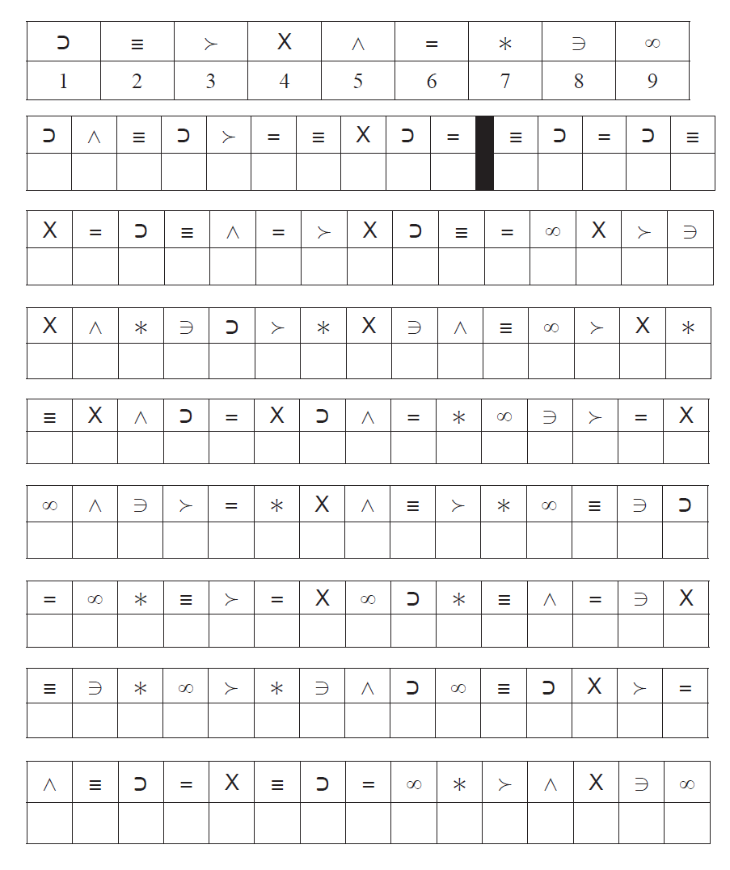

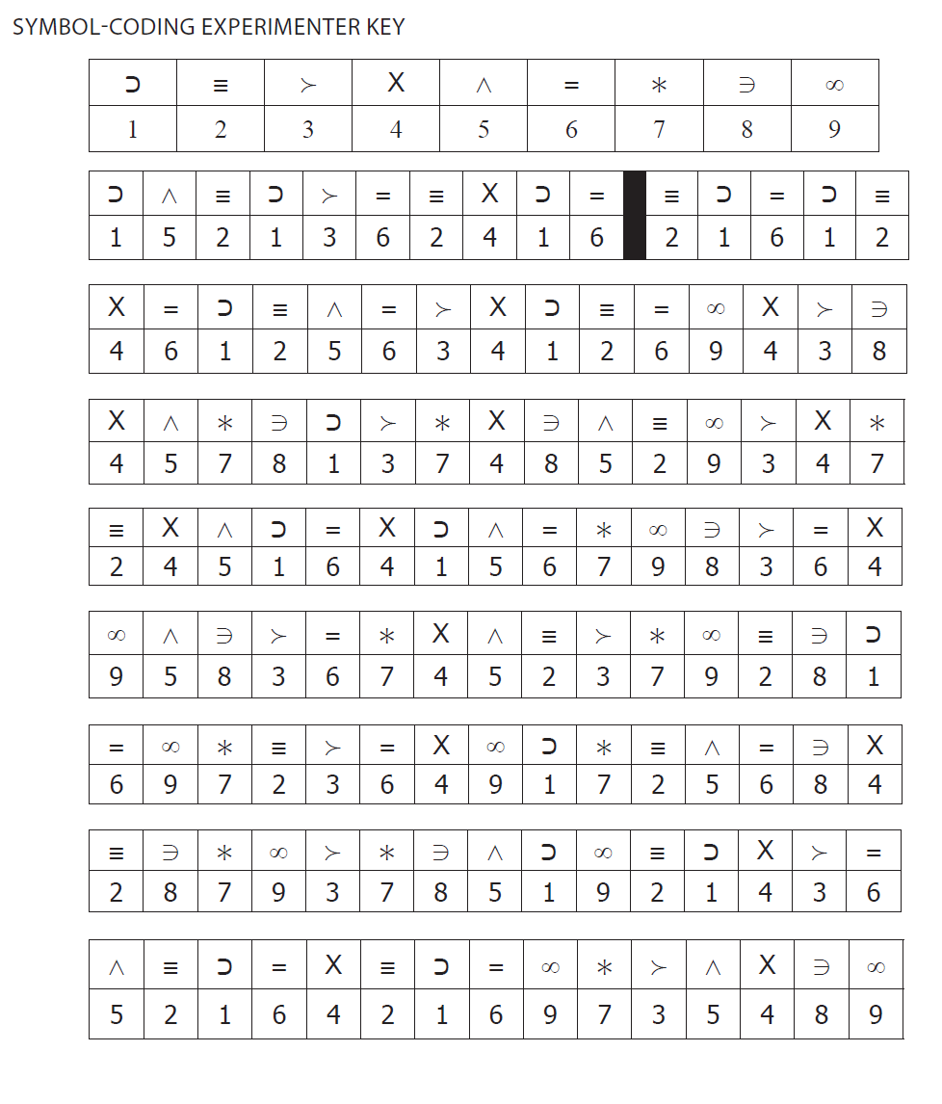

We are interested to know whether people are able to complete these questions in face to face appointments with their care team or not: Could you let us know how you completed these questions by ticking the box below?

|  |  |  |
| --- | --- | --- |
| 1 | I completed these questions with the service user in their home in a face to face appointment |  |
| 2 | I completed these questions with the service user in a service in a face to face appointment |  |
| 3 | I completed these questions with the service user over the phone (audio only) |  |
| 4 | I completed these questions with the service user over a video appointment |  |
| 5 | Other – please state _______________________________________________________________  _______________________________________________________________  _______________________________________________________________ |  |